**PROBLEM #1**

p1url <- "https://emergency.cdc.gov/han/han00384.asp"

fentanyl <- read_html(p1url)

fentanyl

library(rvest)

fentanyl %>%

html_nodes('table') %>%

magrittr::extract2(2) %>%

html_table() -> table

class(table)

colnames(table)[3] <- "Fentanyl seizures"

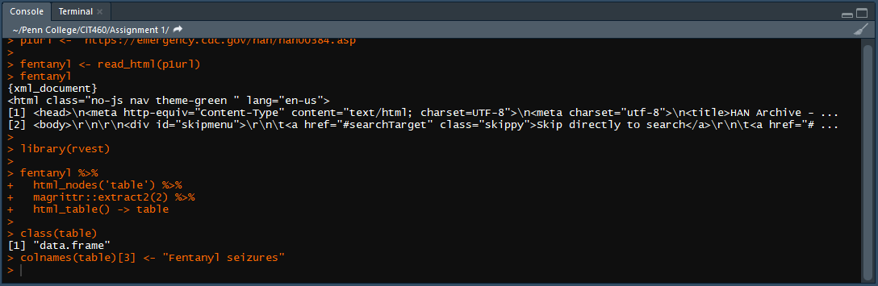

table

states <- head(table$State, 5)

sprintf("States with the most fentanyl seizures: %s, %s, %s, %s, %s",

states[1], states[2], states[3], states[4], states[5])

states <- tail(table$State, 5)

sprintf("States with the fewest fentanyl seizures (among the top ten): %s, %s, %s, %s, %s",

states[5], states[4], states[3], states[2], states[1])

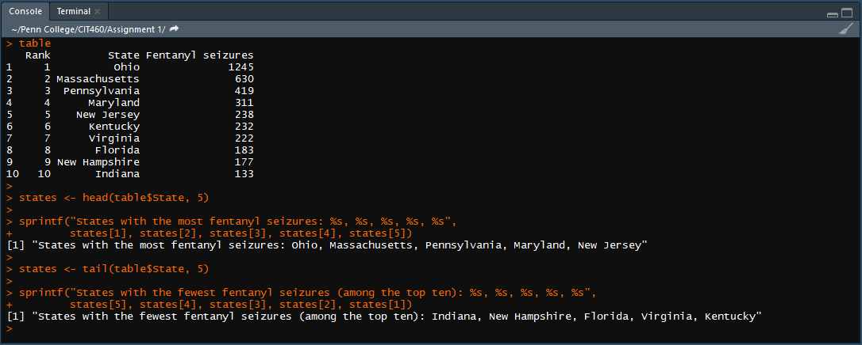

**PROBLEM #2**

p2url <- "https://people.sc.fsu.edu/~jburkardt/data/csv/hurricanes.csv"

library(readr)

hurricanes <- read.table(file = p2url, header = TRUE, sep = ",")

may <- hurricanes[1,seq(3,13)]

june <- hurricanes[2,seq(3,13)]

july <- hurricanes[3,seq(3,13)]

august <- hurricanes[4,seq(3,13)]

september <- hurricanes[5,seq(3,13)]

october <- hurricanes[6,seq(3,13)]

november <- hurricanes[7,seq(3,13)]

december <- hurricanes[8,seq(3,13)]

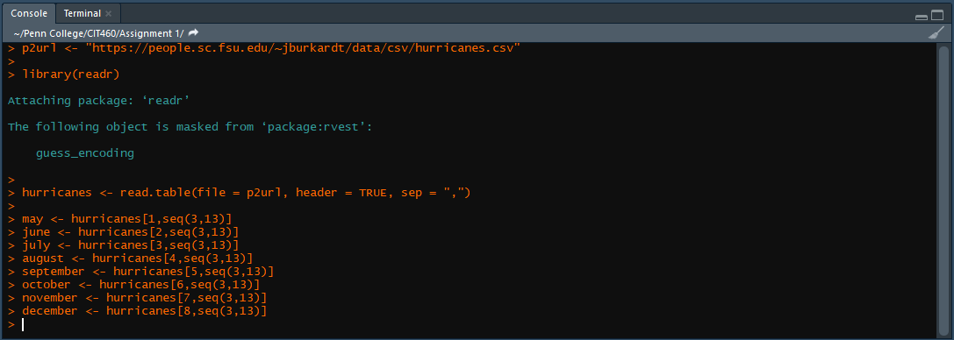

pre2010may <- as.numeric(may[1,seq(1,5)])

post2010may <- as.numeric(may[1,seq(6,11)])

pre2010jun <- as.numeric(june[1,seq(1,5)])

post2010jun <- as.numeric(june[1,seq(6,11)])

pre2010jul <- as.numeric(july[1,seq(1,5)])

post2010jul <- as.numeric(july[1,seq(6,11)])

pre2010aug <- as.numeric(august[1,seq(1,5)])

post2010aug <- as.numeric(august[1,seq(6,11)])

pre2010sep <- as.numeric(september[1,seq(1,5)])

post2010sep <- as.numeric(september[1,seq(6,11)])

pre2010oct <- as.numeric(october[1,seq(1,5)])

post2010oct <- as.numeric(october[1,seq(6,11)])

pre2010nov <- as.numeric(november[1,seq(1,5)])

post2010nov <- as.numeric(november[1,seq(6,11)])

pre2010dec <- as.numeric(december[1,seq(1,5)])

post2010dec <- as.numeric(december[1,seq(6,11)])

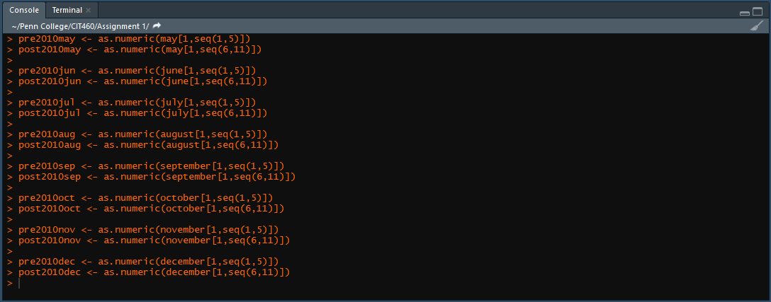

pre2010mean <- c(mean(pre2010may), mean(pre2010jun), mean(pre2010jul), mean(pre2010aug),

mean(pre2010sep), mean(pre2010oct), mean(pre2010nov), mean(pre2010dec))

hurricanes$"Average Pre-2010" <- pre2010mean

post2010mean <- c(mean(post2010may), mean(post2010jun), mean(post2010jul), mean(post2010aug),

mean(post2010sep), mean(post2010oct), mean(post2010nov), mean(post2010dec))

hurricanes$"Average Post-2010" <- post2010mean

library(ggplot2)

ggplot(data = hurricanes, aes(x = Month)) +

geom_line(aes(y = hurricanes[14], group = 1, color = "Average Pre-2010")) +

geom_line(aes(y = hurricanes[15], group = 1, color = "Average Post-2010")) +

ylab("Average Number of Hurricanes") + ggtitle("Average Number of Hurricanes by Month")

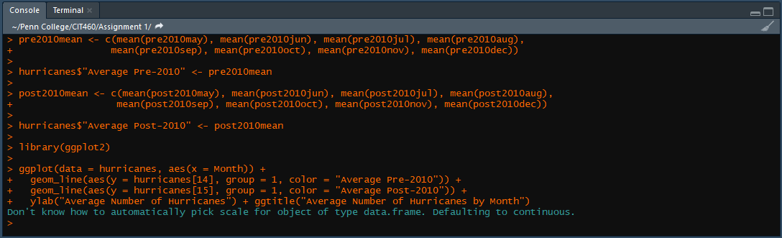

**PROBLEM #3**

setwd("C:/Users/Eric/Documents/Penn College/CIT460/Assignment 1")

library(readxl)

opioids <- read_excel("Assignment 1 opioid.xlsx")

opioids <- opioids[-c(1, 2, 3, 4), ]

opioids <- opioids[-seq(41,54), ]

colnames(opioids)[1] <- "Descriptor"

colnames(opioids)[seq(2,18)] <- seq(1999, 2015)

opioids <- opioids[-c(1), ]

deathsMale <- as.numeric(opioids[3, seq(5,18)])

deathsFemale <- as.numeric(opioids[2, seq(5,18)])

deathsTotal <- as.numeric(opioids[1, seq(5,18)])

deathsFrame <- data.frame(v1 = seq(2002,2015), v2 = deathsMale, v3 = deathsFemale, v4 = deathsTotal)

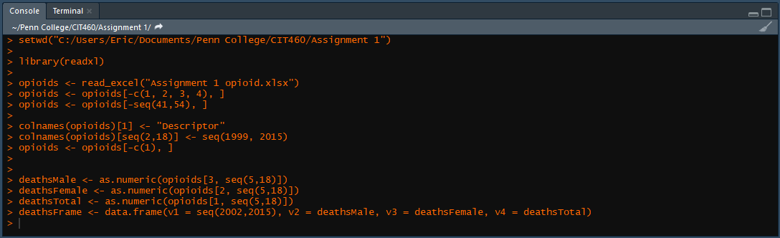

ggplot(data = deathsFrame, aes(x = v1)) +

geom_bar(aes(y = v4, fill = "Total"), stat = "identity") +

geom_line(aes(y = v2, color = "Men"), group = 1, size = 1) +

geom_line(aes(y = v3, color = "Women"), group = 1, size = 1) +

geom_point(aes(y = v2)) + geom_point(aes(y = v3)) +

scale_fill_manual(values=c("gray")) +

labs(x = "Year", y = "Number of Overdose Deaths") +

ggtitle("Number of Overdose Deaths by Year — All Drugs") +

scale_x_continuous(breaks = seq(2002, 2015, by = 1))

deathsMale <- as.numeric(opioids[9, seq(5,18)])

deathsFemale <- as.numeric(opioids[8, seq(5,18)])

deathsTotal <- as.numeric(opioids[7, seq(5,18)])

deathsFrame <- data.frame(v1 = seq(2002,2015), v2 = deathsMale, v3 = deathsFemale, v4 = deathsTotal)

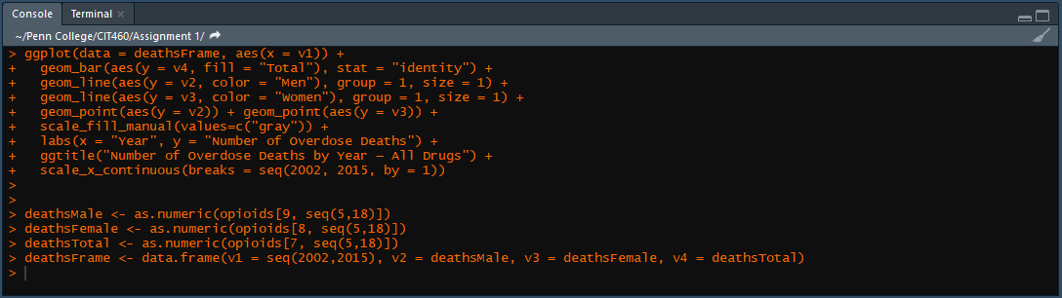

ggplot(data = deathsFrame, aes(x = v1)) +

geom_bar(aes(y = v4, fill = "Total"), stat = "identity") +

geom_line(aes(y = v2, color = "Men"), group = 1, size = 1) +

geom_line(aes(y = v3, color = "Women"), group = 1, size = 1) +

geom_point(aes(y = v2)) + geom_point(aes(y = v3)) +

scale_fill_manual(values=c("gray")) +

labs(x = "Year", y = "Number of Overdose Deaths") +

ggtitle("Number of Overdose Deaths by Year — Opioid Pain Relievers") +

scale_x_continuous(breaks = seq(2002, 2015, by = 1))

deathsMale <- as.numeric(opioids[21, seq(5,18)])

deathsFemale <- as.numeric(opioids[20, seq(5,18)])

deathsTotal <- as.numeric(opioids[19, seq(5,18)])

deathsFrame <- data.frame(v1 = seq(2002,2015), v2 = deathsMale, v3 = deathsFemale, v4 = deathsTotal)

ggplot(data = deathsFrame, aes(x = v1)) +

geom_bar(aes(y = v4, fill = "Total"), stat = "identity") +

geom_line(aes(y = v2, color = "Men"), group = 1, size = 1) +

geom_line(aes(y = v3, color = "Women"), group = 1, size = 1) +

geom_point(aes(y = v2)) + geom_point(aes(y = v3)) +

scale_fill_manual(values=c("gray")) +

labs(x = "Year", y = "Number of Overdose Deaths") +

ggtitle("Number of Overdose Deaths by Year — Heroin") +

scale_x_continuous(breaks = seq(2002, 2015, by = 1))

